IRB1 40(robotic arm) by default follows IRB1 40amupulationSphere mean when we simulate it than robotic arm follow the transparent sphere (IRB1 40amupulationSphere). During simulation, moving sphere robotic arm move towards the sphere.

You can also create one object which is followed by any other robotic arm in V-REP software by following

This video(https://www.youtube.com/watch?v=BrbjS9MKfbo)

Understand simulation:

1. path-1 ( where joint line without “i” dot and “t” horizontal line)

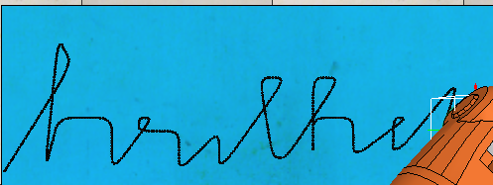

2.path-2(“i” dot)



3.path-3(“t” horizontal line)



4. path-4(“i” dot)



**Combining all makes:**

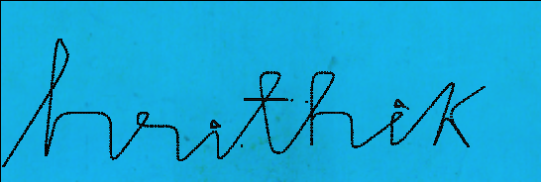

**Understanding camera:**

1.Add->camera (then orient it according to interest)

2.Select camera then add->associate child script-> non threaded script

3.write same code :

function sysCall_init()

floorCam=sim.getObjectHandle('Camera')

floorView=sim.floatingViewAdd(0.8,0.8,1,1,0)

sim.adjustView(floorView,floorCam,64)

end

**Understand camera code:**

1. floorCam=sim.getObjectHandle('Camera')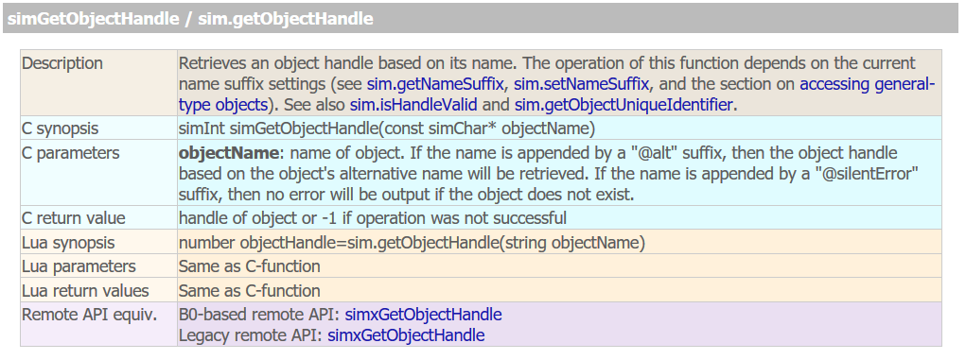

2. floorView=sim.floatingViewAdd(0.8,0.8,1,1,0)

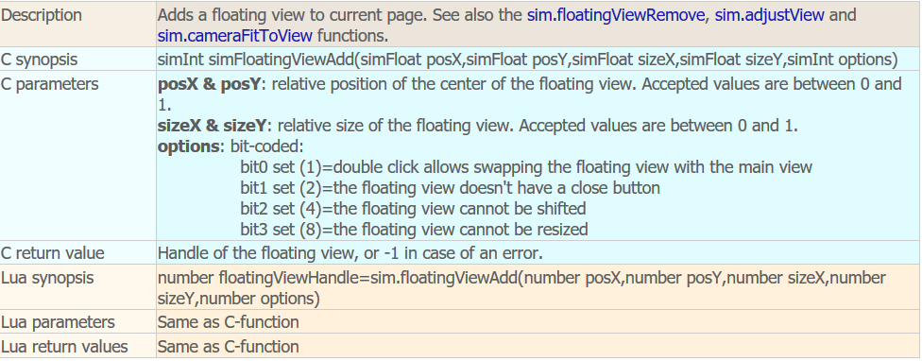

3. sim.adjustView(floorView,floorCam,64)

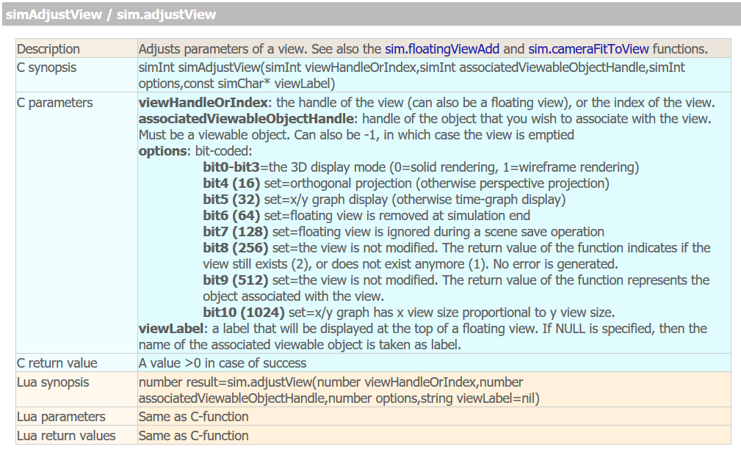

**Understanding path simulation:**

Understand simulation :

1.I have created a path

( follow link to understand how to create path <https://www.youtube.com/watch?v=P6-qrxsaChg>)

2. Create a non threaded script(select IRB1 40amupulationSphere than add->associate child script-> non threaded script)

3. <https://humanrobotartsynth.space/tutorials/v_rep/path_following.html>

Using this link I have copied the code and pasted in non threaded script of IRB1 40amupulationSphere

Understand code (non threaded script of IRB1 40amupulationSphere)

1. local pathHandle = sim.getObjectHandle('Path')

‘Path’- name should be same as the name of the path you created . pathHandle is the variable name given to ‘Path’

2. sim.followPath(thisObjectHandle, pathHandle, changePositionOnly, 0, 0.17,15)

Means:

sim.followPath(number objectHandle,number pathHandle,

number positionAndOrOrientation,number relativeDistanceOnPath,number velocity,number accel)

**Parameters:**

**objectHandle**: handle of the object to be moved

**pathHandle**: handle of the path object

**positionAndOrOrientation**: a value between 1 and 3 (1: only position is modified, 2: only orientation is modified, 3: position and orientation is modified). Can be nil in which case 3 is applied.

**relativeDistanceOnPath**: a value between 0 and 1, where 0 is the beginning of the path, and 1 the end of the path. Make sure you selected the appropriate path length calculation method (refer to the path position calculation method section).

**velocity**: movement nominal velocity.

**accel**: the acceleration/deceleration.

3.sim.getSimulationTime()- return the simulation time during simulation

4. if (sim.getSimulationTime()-T_last_inserted >33) then

If simulation time is more than 33s than this method help to make arm follow path-2

Same way in code : path-1 to path-2 than path-3 than path-4 are followed.